MySQL Assignment
DDL Commands & Constraints
1. Introduction
This assignment demonstrates the use of MySQL Data Definition Language (DDL) commands and constraints for creating and managing an Employee Database. The main objective is to create an employee database containing the required tables, modify the table structures using DDL commands, rename and remove tables, and apply appropriate constraints to maintain data accuracy and integrity.
2. Objectives
- To create a database using CREATE DATABASE.
- To create tables using CREATE TABLE.
- To modify table structures using ALTER TABLE.
- To rename tables using RENAME TABLE.
- To remove all records using TRUNCATE.
- To delete tables and databases using DROP.
- To apply primary key, unique, not-null, check, default, and foreign key constraints.
- To maintain relationships between the tables.
3.DDL Commands
First, the employee database was created.
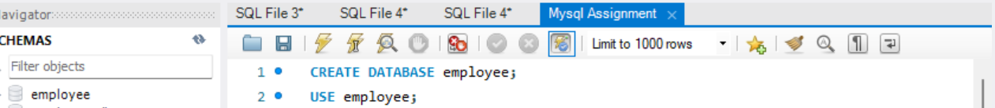

3.1.Table Creation (CREATE):
Write the SQL statements to create a database named “employee” and the following tables based on the provided schema:
⦿ Departments
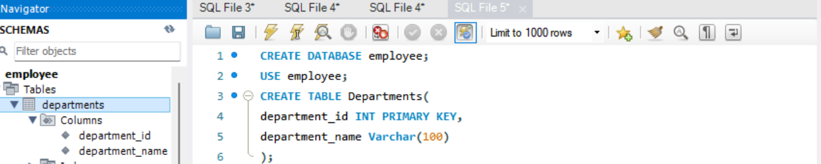
⦿ Location
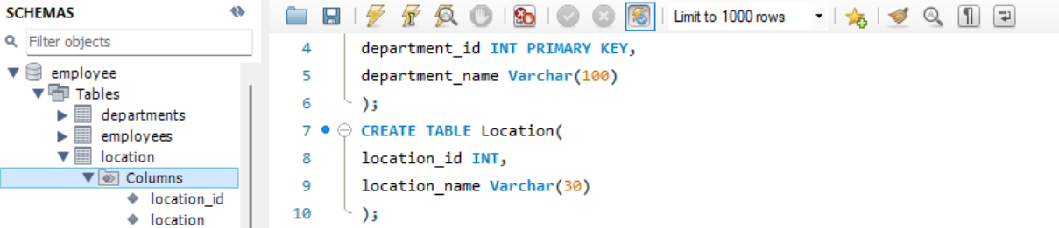
⦿ Employees
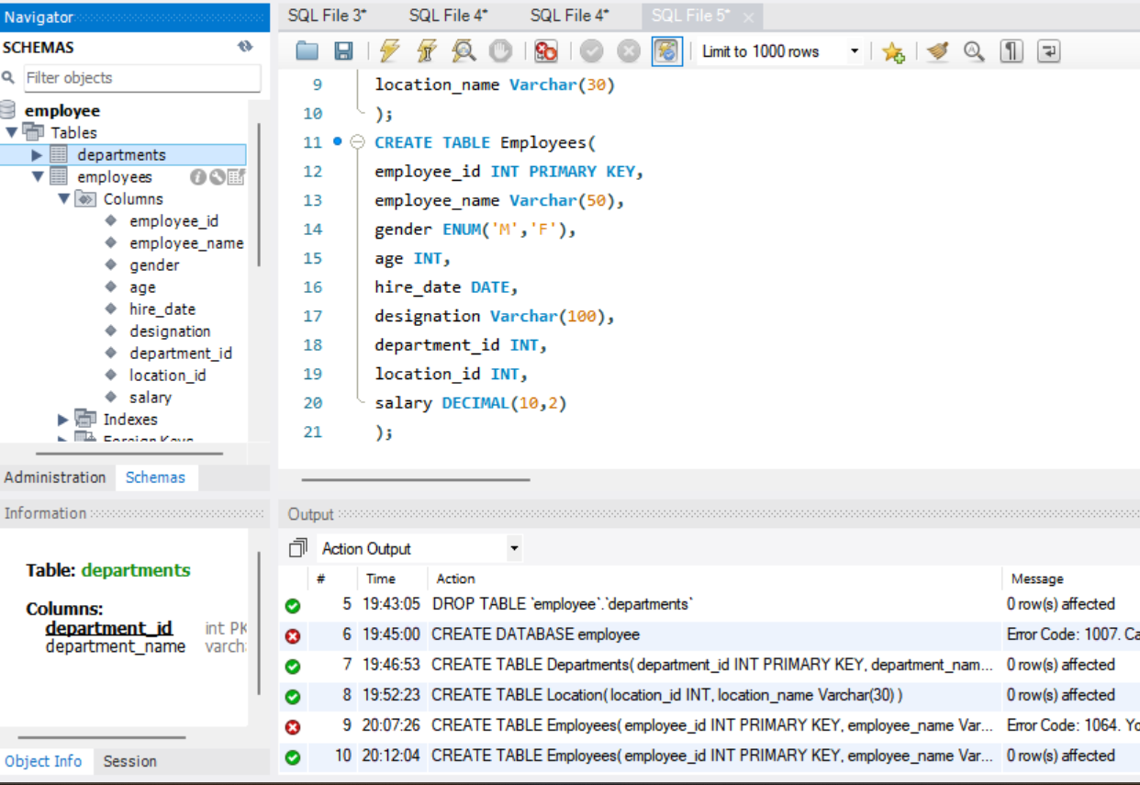
3.2. Table Alteration (ALTER):
Consider the following scenarios and write the SQL statements to alter the structure of the tables accordingly:
⦿ Add a new column named "email" to the Employees table to store employee email addresses.
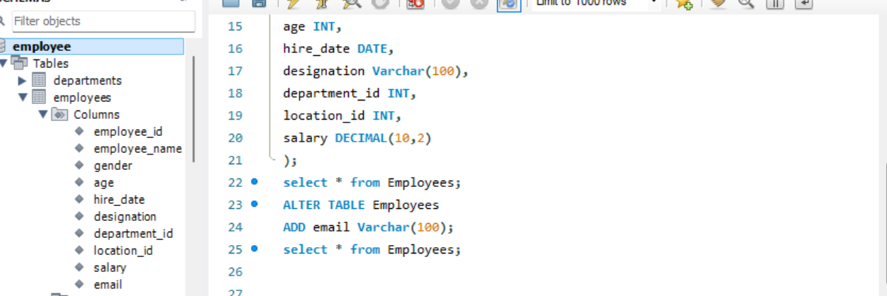
⦿ Modify the data type of the "designation" column in the Employees table to support a wider range of values.
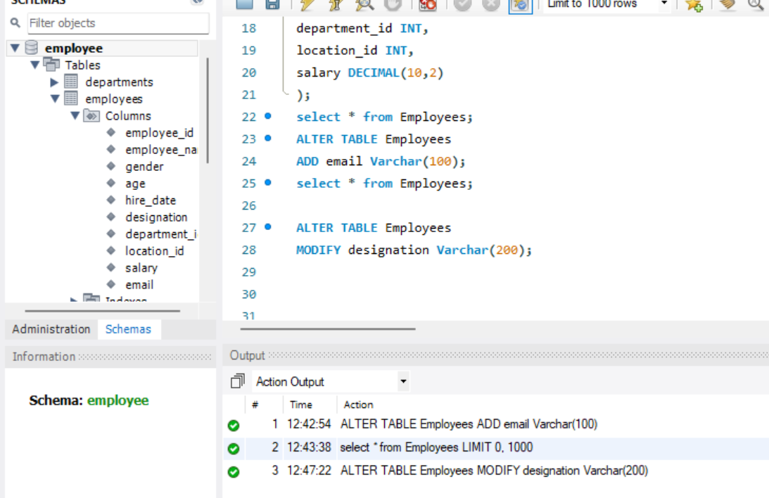

⦿ Drop the “age” column from the Employees table.
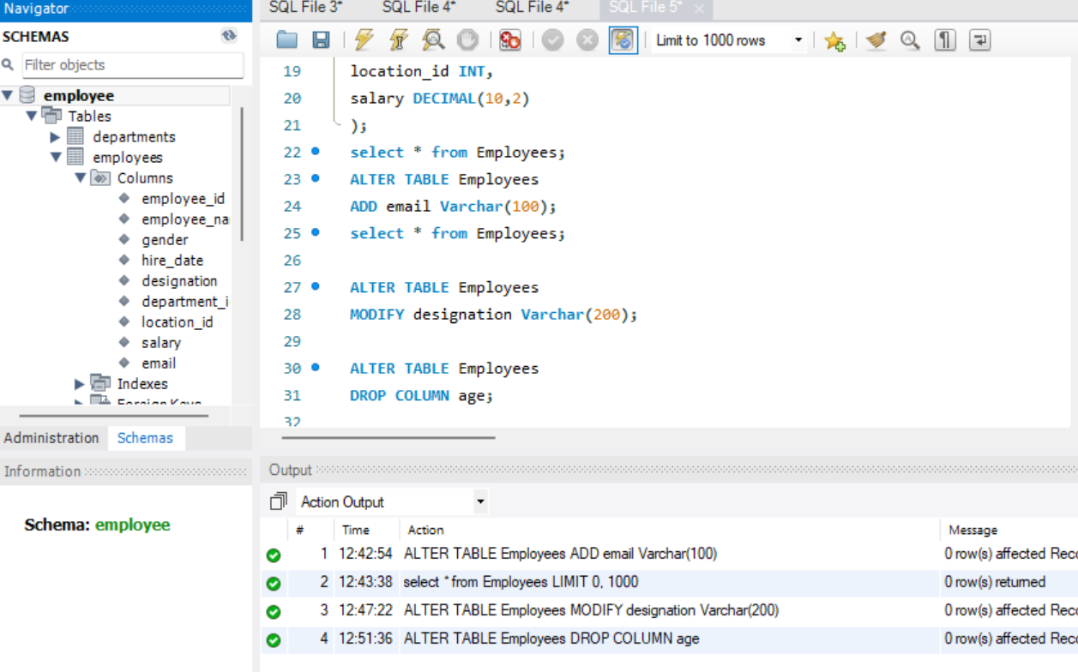
⦿ Rename the “hire_date” column to “date_of_joining”.
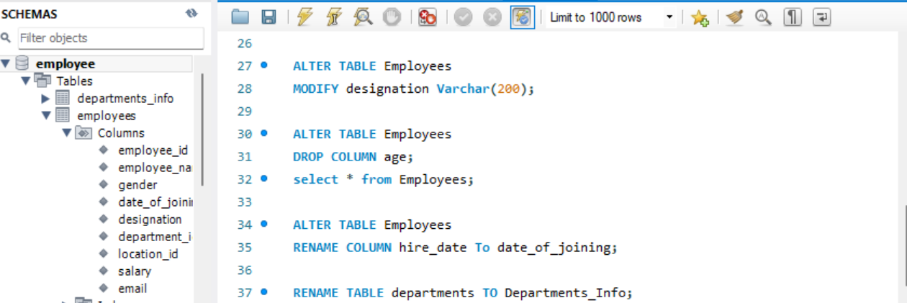
3.3. Table Renaming (RENAME):
Rewrite the SQL statements to rename the following tables:
⦿ Rename the "Departments" table to "Departments_Info".

⦿ Rename the "Location" table to "Locations".
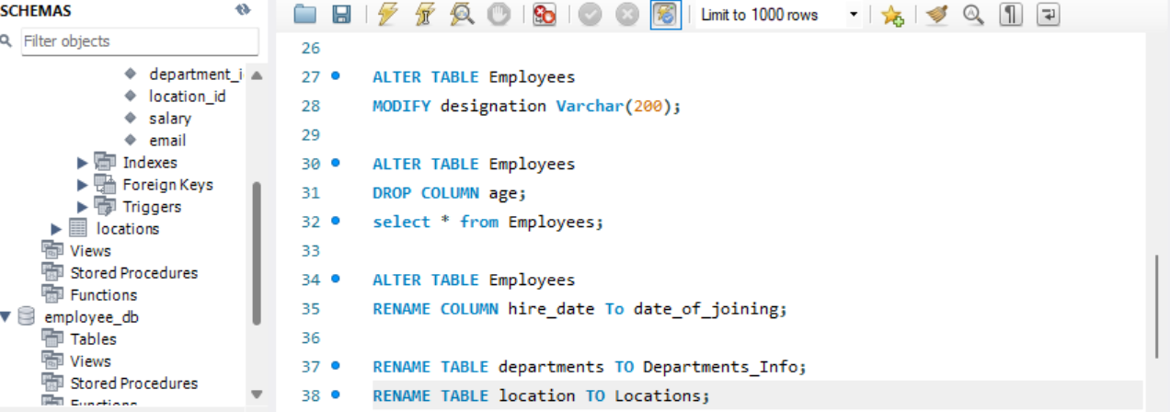
3.4. Table Truncation (TRUNCATE):
Write an SQL statement to truncate the Employees table.
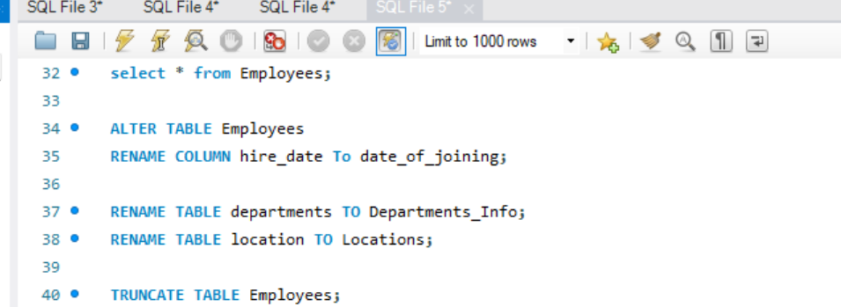
3.5. Database & Table Dropping (DROP):
Write the SQL statements to drop the Employees table and then the “employee” database.
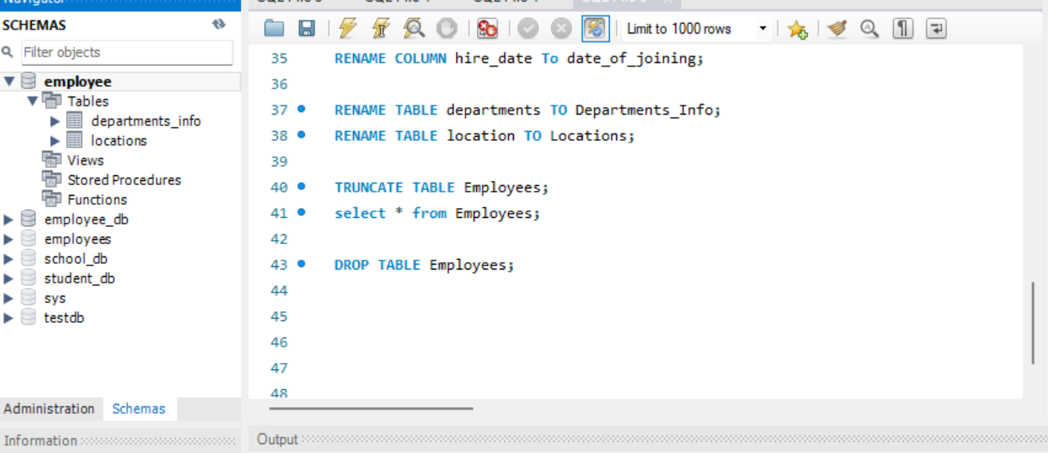
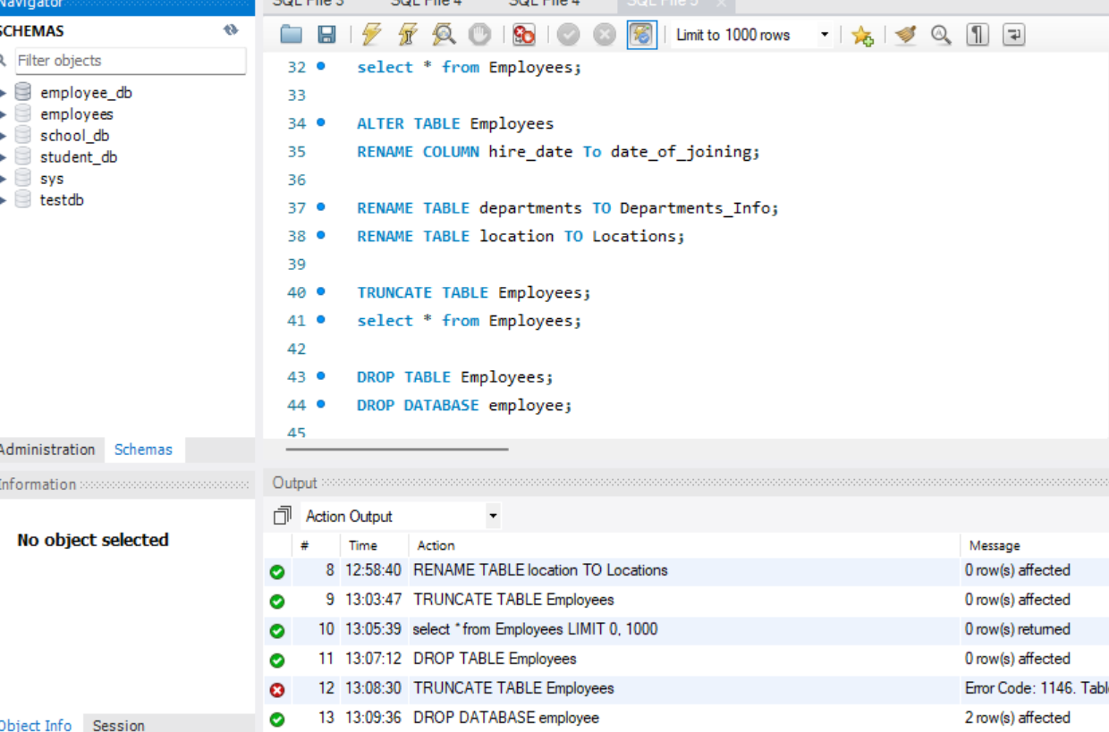
4. CONSTRAINTS
4.1. Database Recreation:
⦿ Drop the 'employee' database if it exists and recreate it using the provided schema, ensuring that all tables are created with the appropriate constraints as instructed.
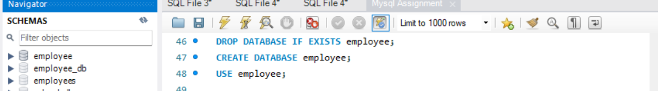
4.2. Departments Table:
⦿ Ensure that the "department_id" uniquely identifies each department.
⦿ Set up constraints on the "department_name" to avoid duplicate and null entries.
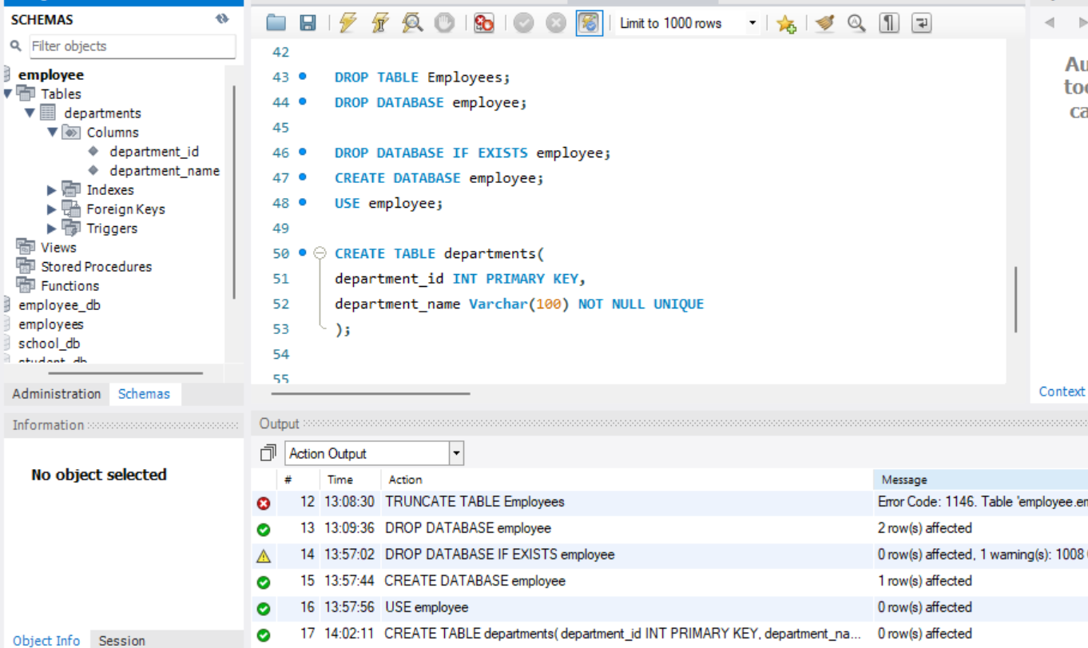
4.3. Location Table:
⦿ Establish a mechanism to automatically generate unique identifiers for each location, ensuring that they are incremented sequentially.
⦿ Implement constraints to prevent the insertion of null and duplicate locations
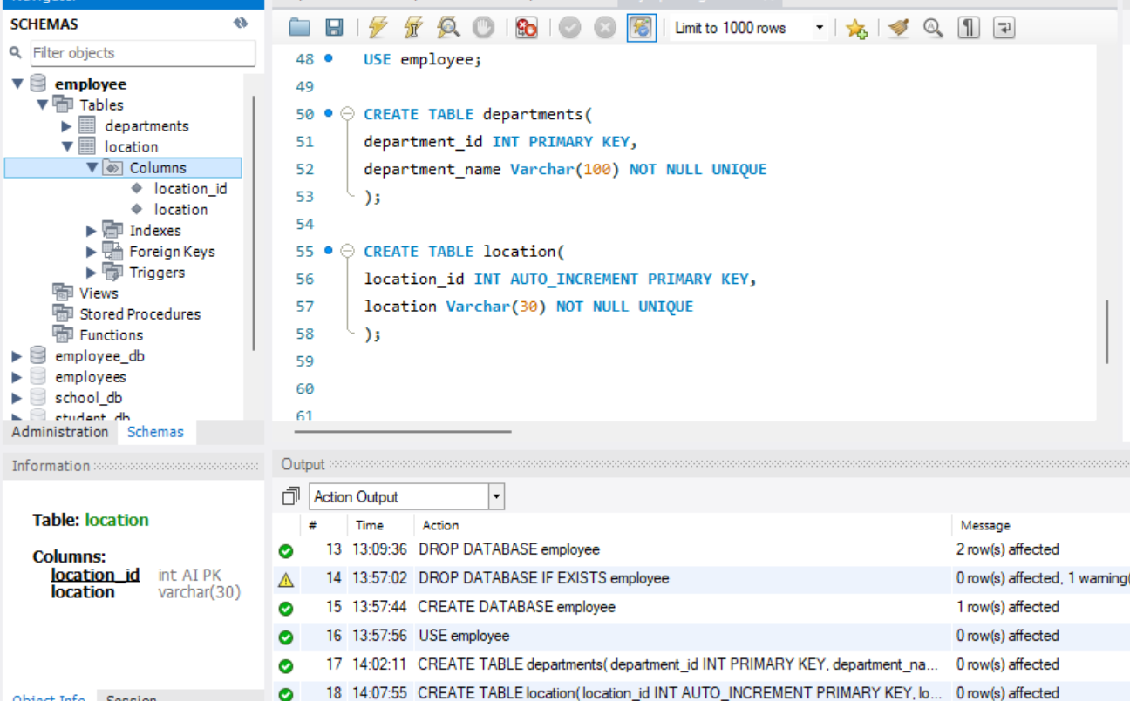
4.4. Employees Table:
⦿ Guarantee that each employee has a distinct identifier.
⦿ Create a restriction to ensure that the employee's name is always provided.
⦿ Limit the acceptable values for the "gender" field to only 'M' or 'F'.
⦿ Enforce a condition to ensure that the employee's age is 18 or above.
⦿ Automatically assign the current date to the "hire_date" field if not specified.
⦿ Establish links between the "department_id" and "location_id" fields in the "employees" table and their respective tables.
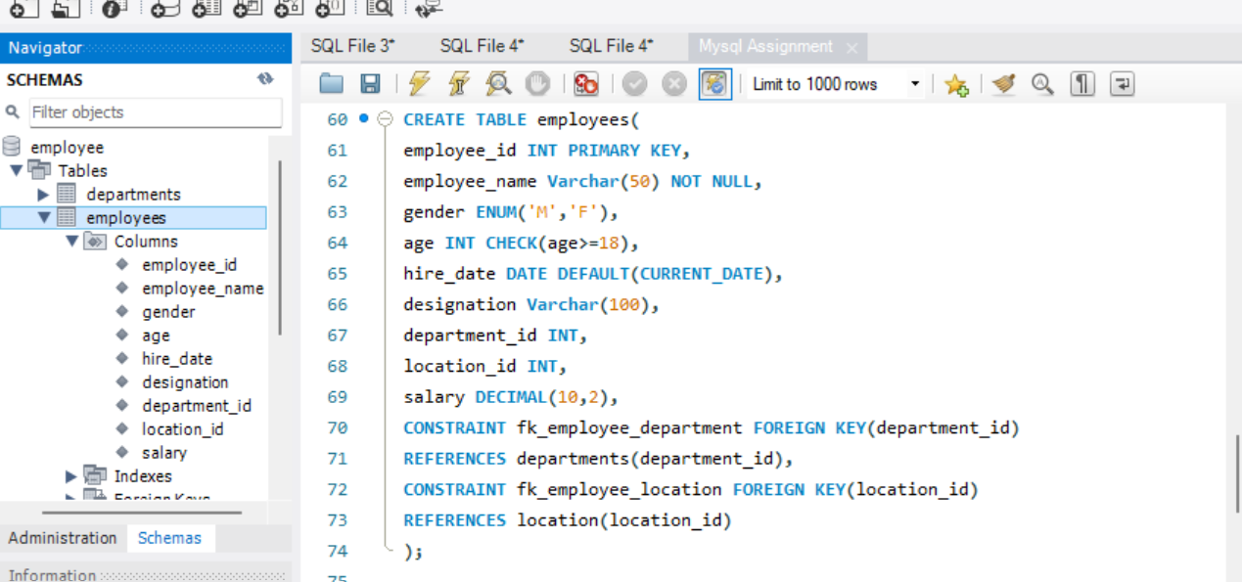
5. Conclusion
This assignment demonstrated the practical implementation of DDL commands and constraints in MySQL. The Employee Database was created with Departments, Location, and Employees tables. Various DDL operations such as CREATE, ALTER, RENAME, TRUNCATE, and DROP were performed.
Constraints such as PRIMARY KEY, NOT NULL, UNIQUE, AUTO_INCREMENT, CHECK, DEFAULT, and FOREIGN KEY were applied to maintain data integrity and establish relationships between tables. Overall, the assignment helped in understanding how MySQL databases and table structures can be created, modified, controlled, and maintained effectively.

